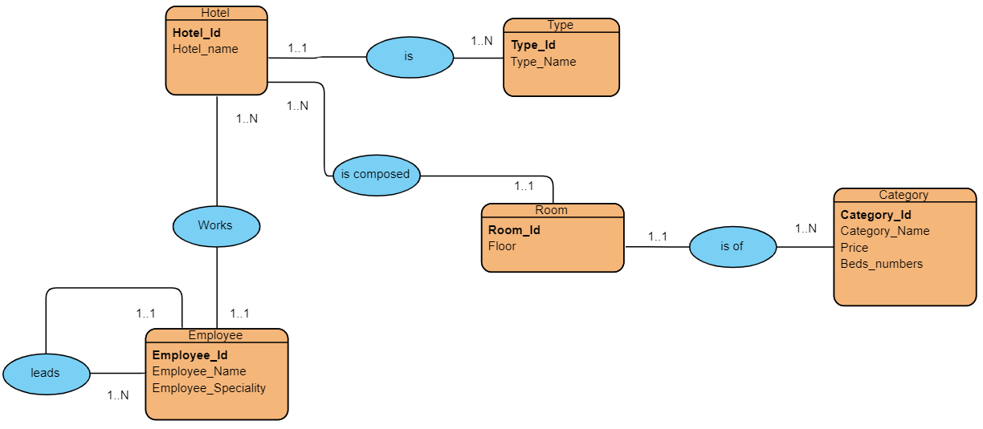

**Relational model :**

**Hotel( Hotel_id , Hotel_name , #Type_id)**

**Type( Type_id , Type_Name)**

**Room(Room_id, Floor, #Hotel_id , #Category_id)**

**Category(Category_id , Category_Name, Price , Beds_numbers )**

**Employee(Employee_id, Employee_Name , Employee_Speciality, #director_id , #Hotel_id)**